Translating Scratch Cards

# Introduction

This document describes how to translate the Scratch Cards into a target language with Dutch as example. I describe the tools and the workflow. I use Windows as platform. There will be other platforms, other tools and other workflows. But hopefully this document helps by providing a way how to do it and achieve a high graphical quality.

# Changelog

Since we distribute this document via Github, we may not always update the filename after a change. So here you can see whether you still have the most recent version.

|  |  |
| --- | --- |
| Date | Change |
|  |  |
|  |  |

# Print Quality consideration

In the Dutch team, we want to print these cards. And since we prefer a bit bigger size than the original cards, we are very much focused on not losing any resolution unnecessarily. These are the outputs that we want to generate:

* Cards on the original size of 127.0 x 177.8 mm with a small file size for on-line viewing. We deliver both the individual files as well as the whole set in the order as they are on-line as well.
* Cards on the original size of 127.0 x 177.8 which are in resolution of at least 300 dpi and use colors in CMYK color scheme so that it is ready for sending to a print shop.
* Cards on the 20% enlarged size of 152.4 x 213.6 mm in still at least 300 dpi and colors in CMYK coding, also ready be sent to a print shop.

Unfortunately, the desire for high resolution is already a bit countered by the fact that resolution of the original material that was delivered was in a Powerpoint file with a setting for graphical objects of max 220 dpi.

# Check the tools

I use the following tools / material

* Windows 10
* Editing the files: Powerpoint 2019
* Making screenshots: Windows 10 using the Windows + Shift + S key
* Editing the screenshots: GIMP <https://www.gimp.org/>
* Making the PDF files: doPDF 10 <https://www.dopdf.com/>
* On-line checking PDF files for resolution: <http://pdf-analyser.edpsciences.org/>
* Preflight checking: <https://www.check4print.com/>
* <https://www.bucksdigital.com/pdf-preflight/>
* Fonts:
* Merge PDF files: <https://smallpdf.com/>, <https://pdfux.com/merge-pdf/>,
* PDF24: <https://www.pdf24.org/>
* Offline Scratch app
* Firefox

<https://docs.microsoft.com/nl-nl/office/troubleshoot/powerpoint/change-export-slide-resolution>

<https://github.com/LLK/scratch-resources/tree/master/resources/source/cards/Powerpoint-files>

## Language setting

Of course it does not matter in which language you use the tools. But it may be handy when you want to follow the description in this document to first set the tools to English.

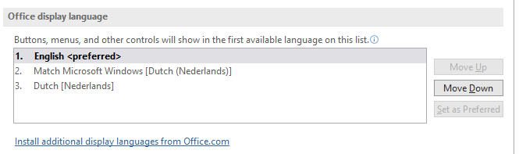Powerpoint: you can download a language pack for English. It is triggered by *File* 🡪 *Options* 🡪 *Language* 🡪 *Install additional display languages from Office.com*. And when you have downloaded and installed the additional language pack, then select English and press *Set as Preferred*. Restart Powerpoint a few times as indicated by the installation process.

## Using multiple screens to make screenshots

In order to maintain best resolution the Scratch blocks should be enlarged as much as possible. You will then often find that the screen is too low. And when you turn the screen into portrait mode you will see that it is too narrow. For that reason, I use multiple screens. I have three monitors connected, but two is generally sufficient. This is what I do:

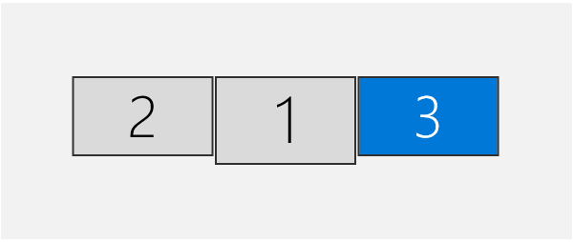My normal configuration is like this. This is also how they physically are located on my desk.

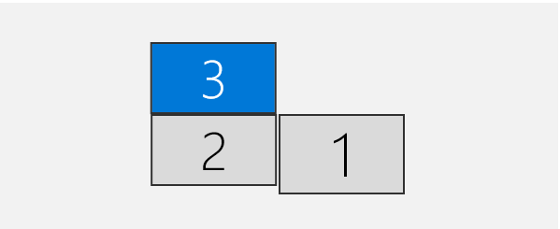When I have to make screenshots of a stack of blocks that is too tall, then I change the setup to:

I make the screenshots spanning monitors 2 and 3. My main monitor is 1. Note that there is no need to change anything in the physical setup of the monitors!

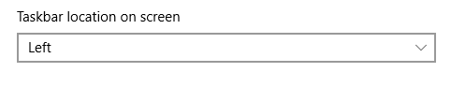What must be done however is to make sure that there is no taskbar in the area to be copied. Either, put the taskbar on the left in this way:

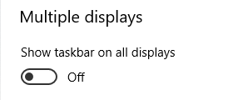Or make sure that the taskbar is only on the main monitor:

# Adapt the Powerpoint setting In every file

Make sure that you make the following settings in every file that you open and before you start updating it.

This is under File 🡪 Options

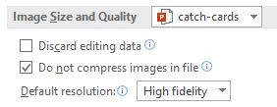 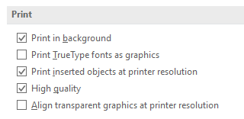

# Translating the texts

You can just select the text and replace it by the text in the target language.

## Dealing with text formatting anomalies

Often a piece of text looks to be centered. However it is not. Rather, the first or the second line is indented. And when you translate into the target language, it does no longer look centered.

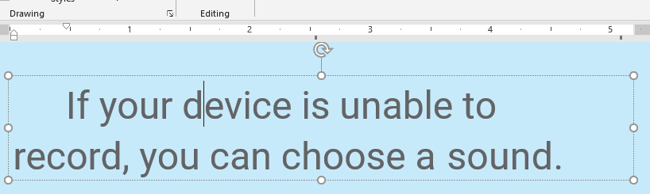

Rather than fiddling around with the indentation settings, fix it with this button

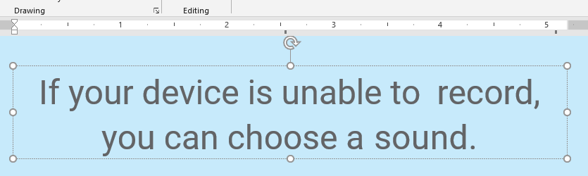And change the indents in this way: all to the left.

# Translating the blocks

## Which editor to use

I have used the Firefox browser to make the screenshots.

## Steps for translating

1. Translate the variables
2. In case there are messages, create a translated message and change the old one wherever it is used.
3. Maximize the image to make the resolution as good as possible.
4. If the stack of blocks is too tall, then use an extra screen if you can, see before.
5. Make a screenshot with Windows + Shift + S.
6. Paste it into GIMP.
7. Press u (Fuzzy Select Tool)
8. Set the Threshold to 30, so that the grid points become parts of the selected area.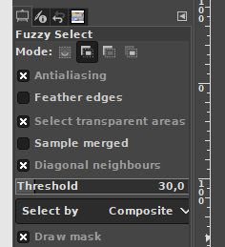
9. Click on the background
10. Press Delete
11. Press Shift + Ctrl + A (Select 🡪 None) 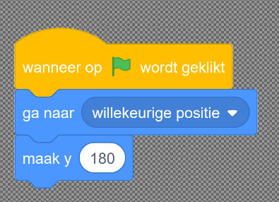
12. If there is still stuff that should be deleted then
    1. Press r (Rectangle Select Tool).
    2. Make sure that *Mode* is *Replace current selection*  
       
    3. Select the area to be deleted
    4. Press *Delete*
13. Press u (Fuzzy Select Tool)
14. With the mouse, click in the transparent area
15. Press Ctrl-i (Invert selection)
16. 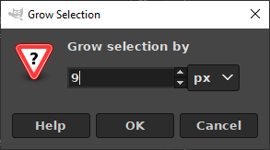Choose: Select 🡪 Grow 🡪 9 pixels 🡪 OK
17. Choose: Select 🡪 Border 🡪 9 pixels 🡪 Border style: Smooth 🡪 OK  
    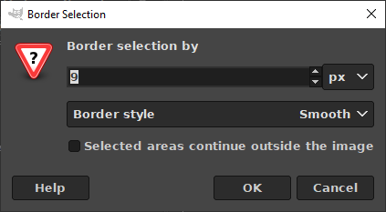
18. Make sure that background is set to white:  
    
19. Press Shift + B (Bucket Fill Tool)
20. With the mouse, click in the selected area. You will see that there is a white lining around the selected area. You will now see:

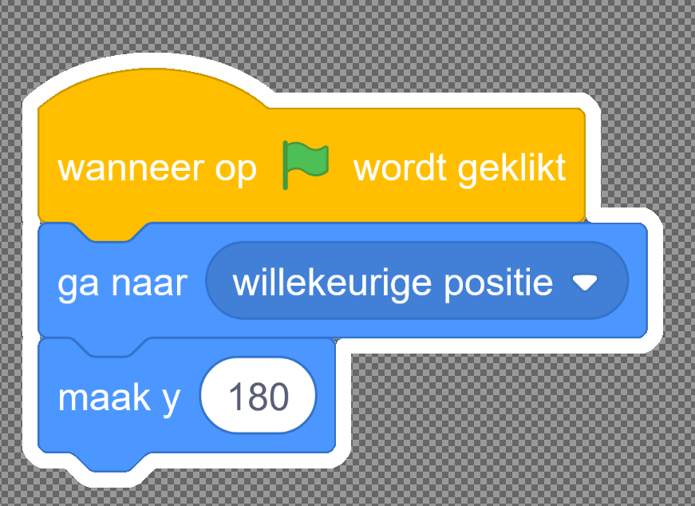

1. Keep the selection and press Image 🡪 Fit Canvas to Selection  
   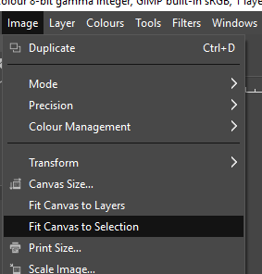
2. Save the project
   1. Choose: File 🡪 Export as 🡪 *filename*.png
   2. Choose: Export
   3. Choose: Compression level: 0
   4. Choose: Export  
      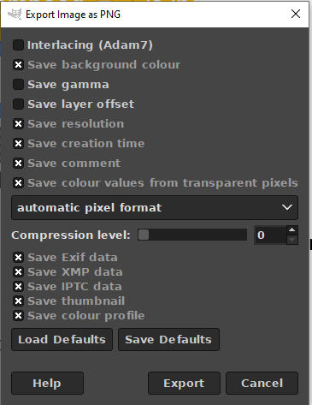

## Making some blocks transparent

In some cases, the new blocks added to a stack are displayed normal, but the old blocks are made half transparent. This is done in this way.

1. After all the steps have been take above (except saving the file), the next must be done
2. Press: u (Fuzzy Select Tool)
3. Make sure that the threshold is set to 0
4. 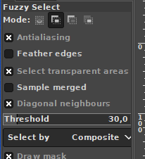  
    
5. Click on the block that need to stay as is.
6. With holding shift down, click the next blocks until you have them all.
7. Choose: Select 🡪 Remove holes
8. Hold shift down and click the border
9. Press: Ctrl I (Select 🡪 Invert)

Gebied uitgrijzen:

* Select 🡪 by color (Shift O)
* Select 🡪 Remove holes
* Select 🡪 Invert (Ctrl I)
* Colours 🡪 Brightness-Contrast

Verschillende kleuren:

* Select 🡪 All
* Colours 🡪 Brightness-Contrast 🡪 -50%
* For each to be highlighted area:
* 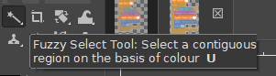Fuzzy Select Tool (Threshold = 0)
  + Click in the area
  + Select 🡪 Remove holes
  + Colours 🡪 Brightness-Contrast 🡪 +50%
* 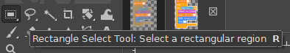Select Rectangle (R)
* Select an area
* Image 🡪 Crop to selection

Filters 🡪 Artistic 🡪 Softglow

Select multiple areas with SHIFT

Blue border around sprite/background/sound button. Shrink 2, border 3 pixels

Put a date vertically on the right hand bottom. Color something that is visible and fits with the design of the card. Format: yyyymmdd

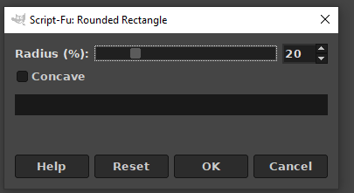

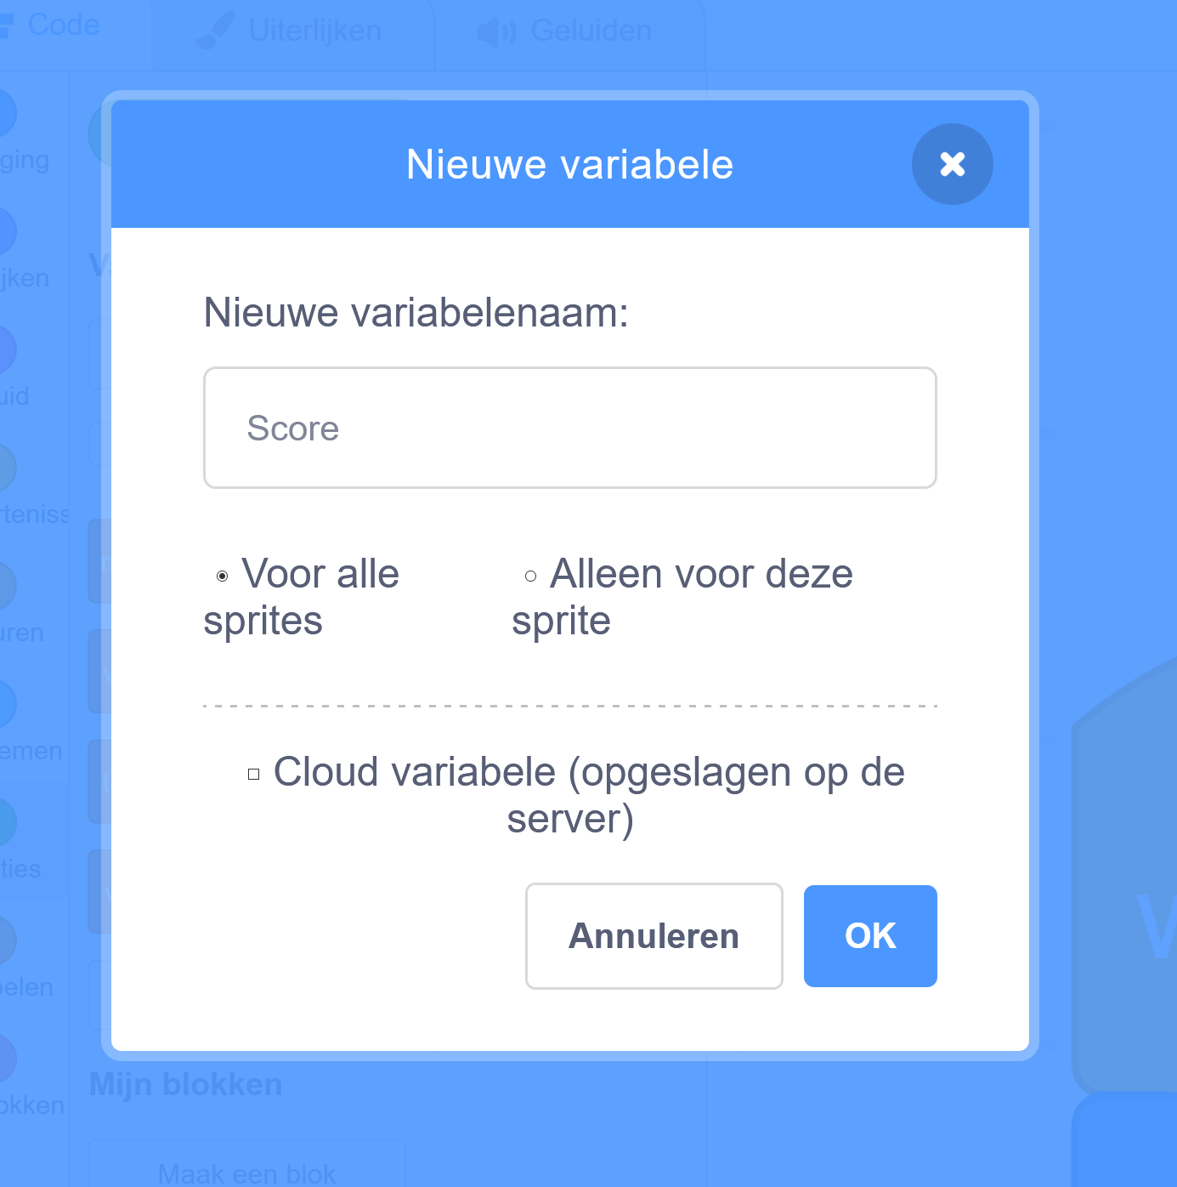

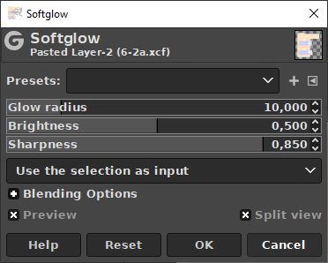

r select rectangle

ctrl I (invert

delete

ctrl i

select 🡪 rounded rectangle

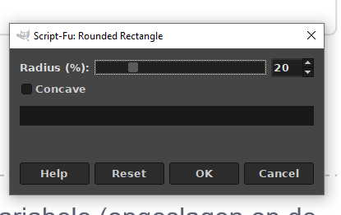

20

OK

Ctrl-i

Delete

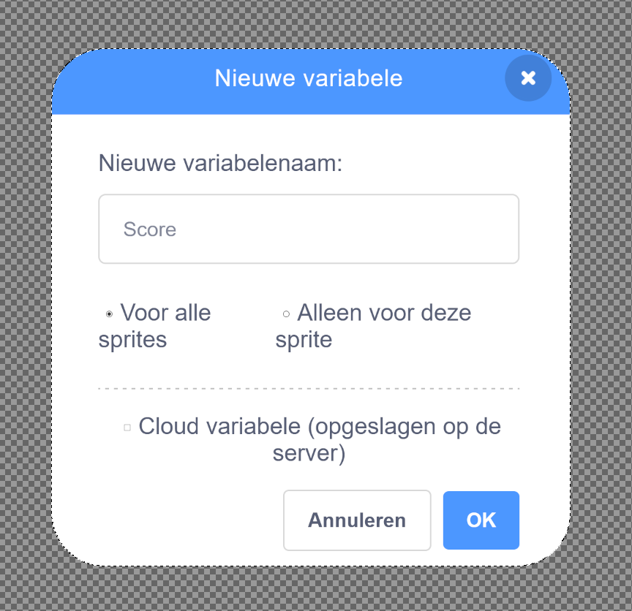

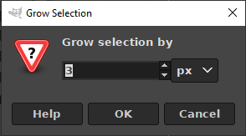Ctrl i

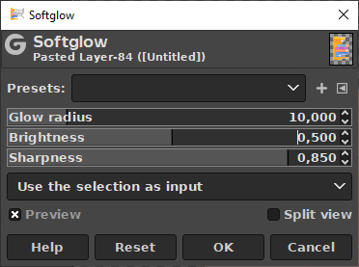

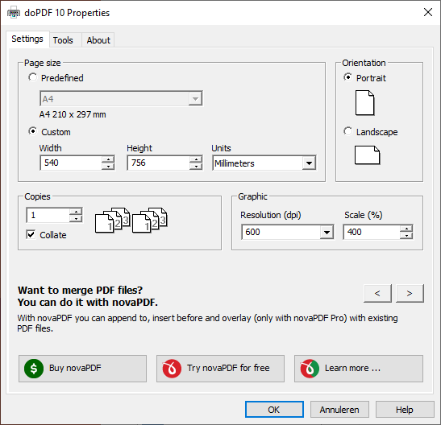Printing

doPDF10

* Page size 540 x 756 mm
* Resolution 300 dpi
* Scale 400%

PDF24

* List the settings
* Print from PDF

Work backwards

Blue border 00a1cb